# C:\Users\nikit\AppData\Local\Microsoft\Windows\INetCache\Content.MSO\239CA1FE.tmp

# Big Data Programming Project: Visualisation

Module name and number: 5011CEM Big Data Programming Project  
Completion or submission date 24/04/2020

# Introduction

The main topic of the project is working with Big Data. I was provided with a large data set and my task was to write a code, in the programming language I prefer, which visualises the data provided. I need to make an easy to interpret overlay on a map which will clearly show changing ozone levels every hour. I have to make 8 different models and add colour blindness accessibility ass well so that users with different types of colour blindness could distinguish between different levels of ozone in the atmosphere.

To plan my work, I used several agile techniques I learned in my previous modules in university. Before working on the code, I made a burndown chart. It helped me to separate how many hours I need to spend a week working on my code and it was useful in scheduling the project with other university activities. Another agile technique I implemented is a User Story Map, it helped me separate the main goals I want to achieve and to see the project from a users perspective and not from a programmers. It also helped me by sorting the main goals and solutions together for an easier access later on. The Agile Product Backlog helped me plan my project even more. It helped me to sort the priority of different tasks and split my work into multiple sprints which I had every week while working on the code. The Professional Development Plan helped me get my most important tasks sorted. I made using four most important questions, which are: “what do I want to learn, what will I do to achieve it, what resources and support will I need and what will be my success criteria”. As well as using the agile techniques I was working on a logbook. Which was a huge help in organising my work. I started by putting the work I plan to be doing in it and the time I allocate for it and after finishing every part I would record the day I finished it and would start planning my next activity. I left different notes in It as well so that when in will be working on a task I’d be able to access them with ease and comfort.

My program achieves to show 8 different models, which are: eurad, mocage lotoseuros, chimere, ensemble, silam, emep and match. I made an easy to understand terminal menu which allows the user to pick the mode they want to see. After picking one of the models my program shows another menu which allows the user to pick 5 different options. The first one is the default one which doesn’t include change of colours of the model while the other 4 do. First allows people with Deuton Colour Blindness to distinguish the information on the map because the model doesn’t include any green colours in it, the second one provides access to people with Protan Colour Blindness, the map doesn’t include any red colours, third one provides access to people with Tritan Colour Blindness, the model doesn’t include any yellow or blue colours and the last option provides access to people with Achromatopsia Colour Blindness, the model is purely in black and white.

# Specification

The complete the project I required a MATLAB licence which was provided to me by the university for free, so I could write my code using official MATLAB software. A decent machine, because MATLAB requires more RAM to run it’s codes and efficiently work with the terminal without losing too much waiting or crashing of the whole software. I used university internet, which provided me with enough speed so I could work without waiting for information to buffer or just long load times in general. When I was working on the code at home, I used my internet as well, which had enough speed as well. And the data that was provided by the university didn’t have any faults in it and I could work with it without any problems.

## Limitations

The biggest limitation I set is not using too much of the data and not give myself too many high goals. If the data would be too large it would take too much of a toll on the hardware and if a user who wants to access my code doesn’t have enough power in his machine, he will won’t be able to see the model at all. And setting realistic goals for myself is always a top priority. If a programmer gives himself to many difficult goals and he will try to achieve all of them he won’t be able to finish even a base of the program.

# Code

The code starts with me assigning two variables a value of 1. I will use the first variable to make the if statement for the main menu which enables a user to choose which model he wants to display and the second variable I use for another if statement which will make a colour-blind menu. After the variables I start making the first if statement, it enables me to make a simple terminal menu which will allow the user to pick which model to display. The menu has 8 choices. The choices are: “eurad, mocage, lotoseuros, chimere, ensemble, silam, emep and match models. After the main menus if statement my code starts a model corresponding to the users input, which was chosen in a previously provided menu. Then I assign three variables, time, longitude and latitude. The values I take from the university provided data file and using MATLABs meshgrid function I assign the values to a new variable called X and Y. Using the previously made variable for time I make a new variable for time to be used in the colour-blind menu. Before making the 2nd menu I format the information which is provided in the model and add a line of code which enable a user to start the model in full screen if he so desires. Later on, I make a for loop which will enable the code to restart itself and update the map for 24 times. In the loop I start by assigning data to the map and adding labels for longitude and latitude, after I make another if statement which will be the menu with the colour-blind options. The menu has 5 options, the default one, which is basically for people without colour-blindness, the option for users who have Deutan colour-blindness, Protan colour-blindness, tritan colour-blindness and achromatopsia colour-blindness. I make different options by utilising MATLAB provided called function colormap, which allows me to change the colour of the map to my liking. After the colour-blind menu I make a colour bar which will show on the right of the map and it will help users see the level of changing ozone levels. And finally in the end of my code I load the coast, plot the map, add shading, add the time above the map, which shows the intervals between the hours.

# Results & Conclusions

In conclusion I achieved to make a working model using MATLAB. My code has 8 different models with 5 different colour variations and every model shows how the ozone changes in the atmosphere every hour for 24 hours. I learned how to utilise a new programming language for myself, and how to interpret and work with large amounts of data. I also learned how to work on a large-scale project alone. This Project helped me learn on how to plan my work according to the schedule that I have been given, how to utilise different agile techniques, how to work with github and have a stable and good version control. In the end the model that I made is able to show a change in the ozone level with utilising different colours.

# Future Work

In the future I could improve my code by adding more models. It will widen the scope of the whole project. Adding a pause button would provide really useful so If a user would want to see the ozone level for a certain time, he could do that with a push of a button. I could improve the model a lot by increasing the time from 24 hours to a month or even a year, it will the model much bigger but the information it will show will increase drastically as well. Improving the actual map could provide very useful, so that a user would be to see more information on the map.

# Appendices



|  |
| --- |
| Coventry University  5011CEM Big Data Programming Project Specification Document  Big Data Analysis: Visualisation |

**01/04/2020**

**Table of Contents**

1. Introduction 3

2. Project Requirements 3

3. Risks and Assumptions 3

4. Out of Scope 3

5. System/ Solution Overview 3

5.1 Context Diagram/ Interface Diagram/ Data Flow Diagram, Application Screen Flow, Sitemap, Process Flow 3

6. Project Management 4

# Introduction

Focus on visualizing the results in an easy to interpret format. This could include, in example an overlay on a map. For this project, CBE data was provided. The visualization should include options for altering the display for clarity and it should consider disability access such as colour blindness.

# Project Requirements

The main requirement is to visualize a presented set of data. It should be easy to understand, easy to access and be accessible to people with colour-blindness.

# Risks and Assumptions

The most major risk related to this project will be not learning programming language MATLAB. A lot of time will need to be allocated to read into, research and fully understand on how to utilise MATLAB to its full extent and make the visualisation code’s quality as high as possible.

One of the main risks will be data corruption because of hardware failure. If the hardware where the project will be stored breaks down and it will be in a unrepairable state, the project will need to be started again from scratch.

# Out of Scope

I do not want to set my goals to an unreachable height, because if I’ll set my goals too high and I’ll allocate time wrongly as well, I won’t be able to have a finished project by the deadline.

# System/ Solution Overview

I’m going to be using programming language MATLAB and utilising its libraries to the full extent. The code will be written in MATLAB R2020a, which I will be able to obtain for academic use, and the software will run on my desktop using Windows 10 OS.

# Context Diagram/ Interface Diagram/ Data Flow Diagram, Application Screen Flow, Sitemap, Process Flow

Burndown Chart:

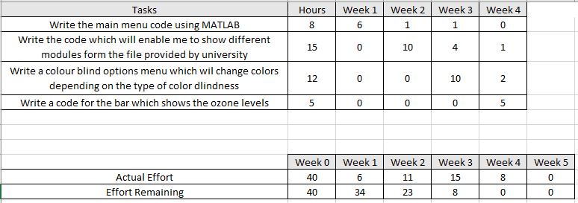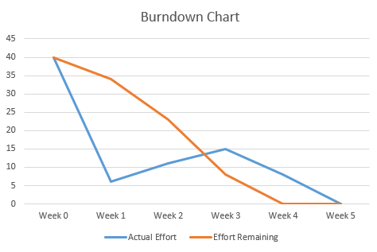

User Story Mapping:

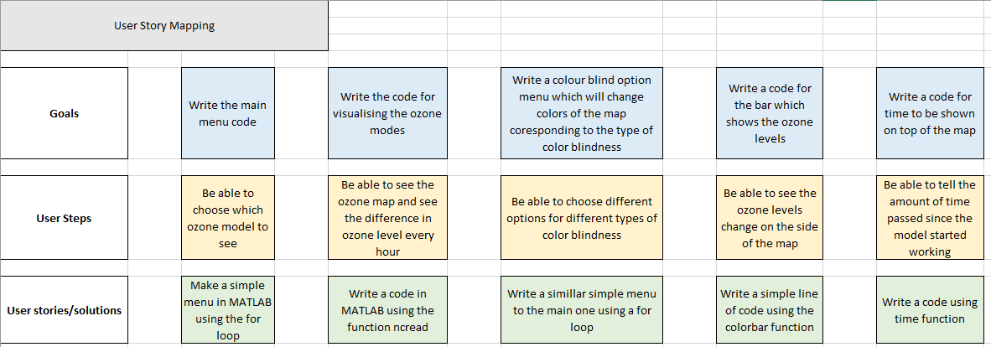

Agile product backlog:

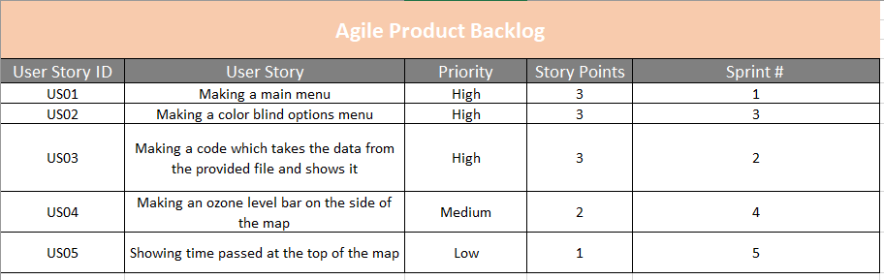

Professional Development Plan:

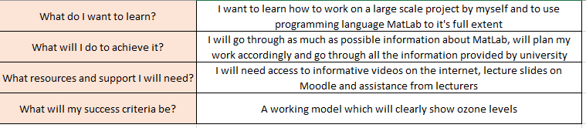

# Project Management

I separated my whole work to steps which I will complete every week. First week I’ll do the main menu, which will be done by using a simple for loop, second week I’ll be working on the main part of the code which will be in charge of showing the model which is provided by the university. Third week I will work on the colour blindness menu, so that a user will be able to pick a different colour blindness mode which changes the colours on the map.